Education Tutor functionality
  - User Experience Preview (proposed)

Overview
This document contains images of a working prototype of the proposed functionality in Stream to improve the user experience for Education Tutors.

Background
A central team manages a pool of external staff (Education Tutors) whose role is to manage and mediate engagement with the University on behalf of a student. This includes all interactions in Stream. This role includes access to all Massey systems using student credentials. Education Tutors are also given guest access to Stream to access Education Tutor-specific support and training resources.
For context, around 30 Education Tutors are currently assigned to students out of a pool of 100. In total, these students are enrolled in around 200 courses. Education Tutors can be assigned 5 or more students. Use of Education Tutors is expected to increase over time.
Historically, both the student and the Education Tutor were enrolled in the course. However, the convenience of accessing Stream using Education Tutor credentials rather than individual student credentials has led to varying practices among tutors, including directly emailing course staff to submit assignments.
Additionally, some newer, purpose-built courses are designed for limited direct digital engagement by the student. This means that the use of student credentials can be minimised or eliminated, thereby simplifying the Education Tutor experience.

Key features
The Education Tutor, using their Education Tutor login (st1nnnnn), can:
- Submit assignments on behalf of students through a central portal.
- Access the course as the student, without needing to log in as the student.
For normal Stream use, they will only need their Education Tutor login - not student credentials.
For the Education Tutor manager:
- Tutor/Student allocations are managed through a simple user interface.
- Education Tutors do not need to be enrolled in course sites.

Login Summary
- The Education Tutor account (st1nnnnn) is the primary Stream login credential. Through it, Education Tutors can access the support and training sites, as well as the specific Education Tutor functionality presented here.
- Student credentials can (or could) be used, but regular usage may be unnecessary.

Education Tutor experience
From their personal menu, they will see new options:
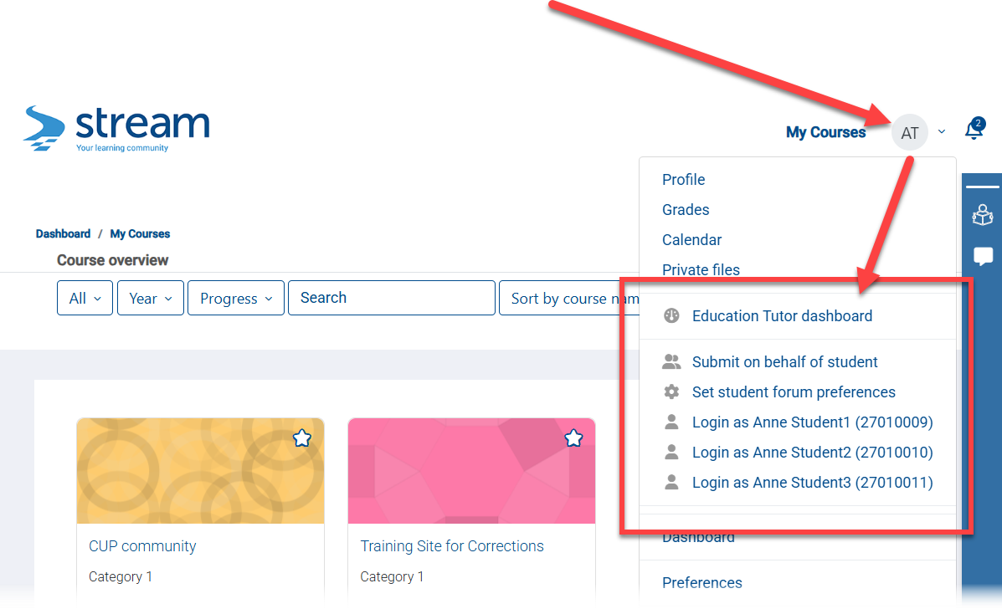

Dashboard
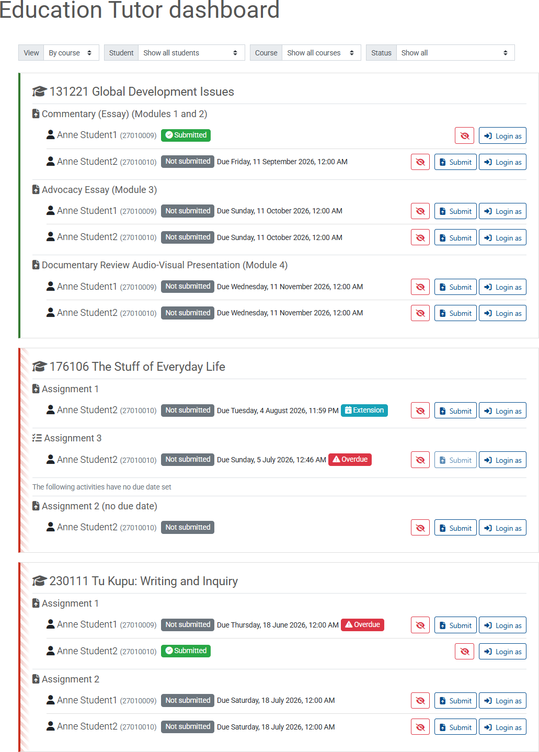

Submit on behalf of student option
Through a central portal, the Education Tutor can submit a standard assignment as the student without logging in as the student. That is, the Education Tutor will not need to enter the course, find the assignment, and navigate the submission interface.
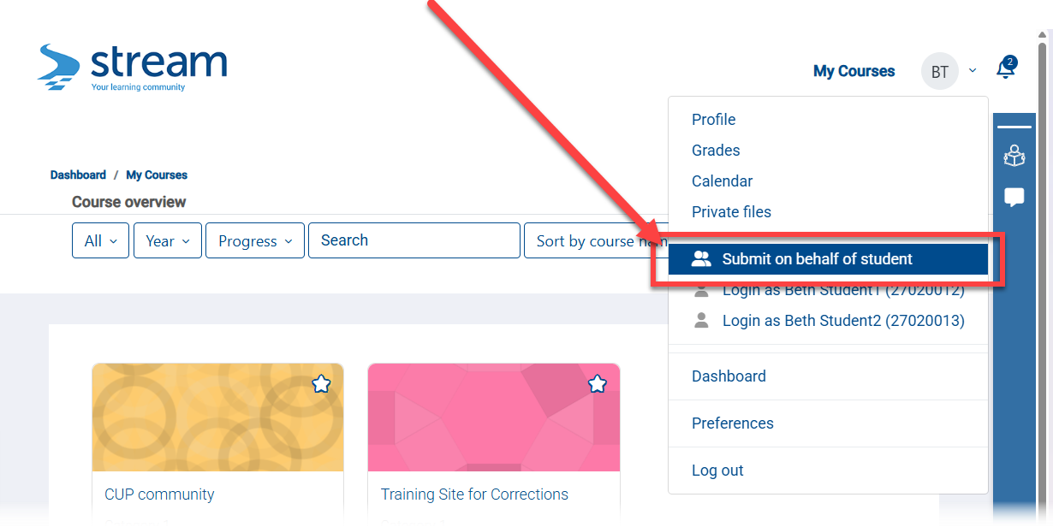
They are then guided to select the student (only their students), course (only the courses their students are in) and assignment (only the assignments in the selected course):
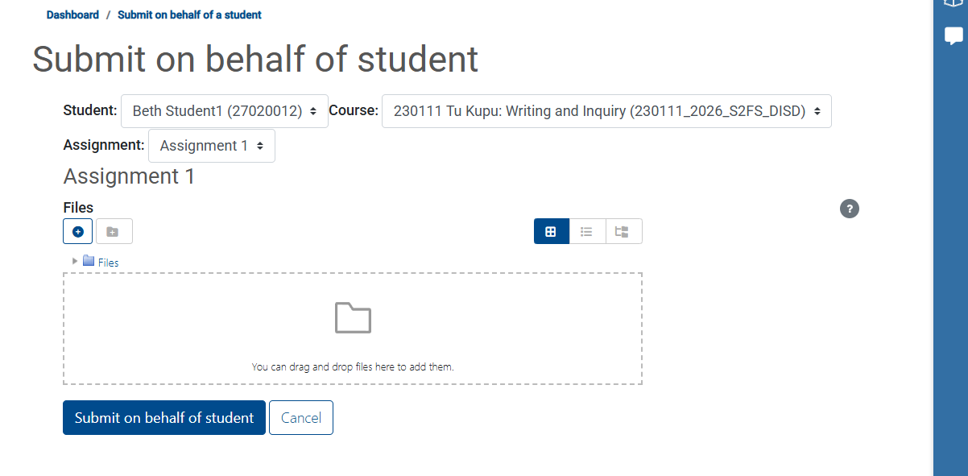
Once the file/s are upload and the Submit button is clicked, then a status screen appears:
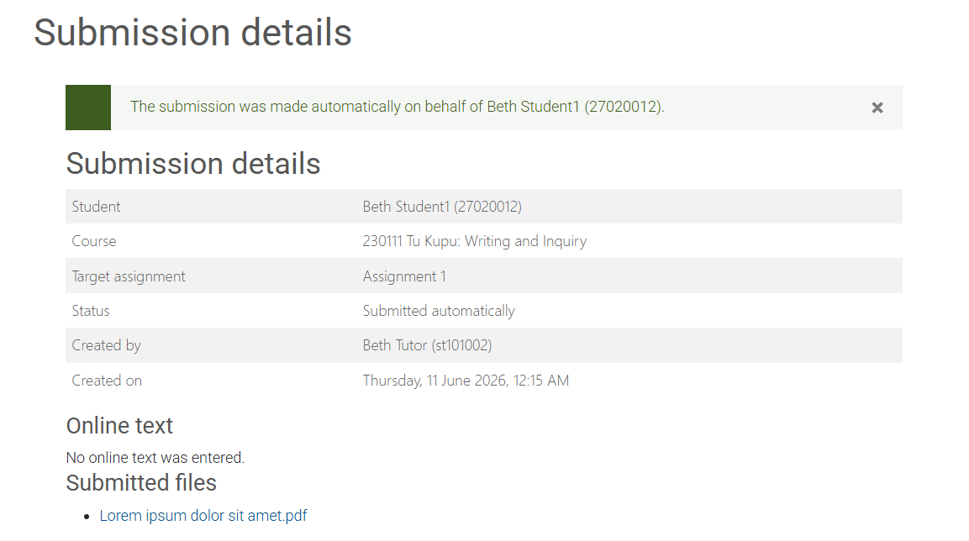

From a coordinator/teacher perspective, the assignment looks like a normal submission:
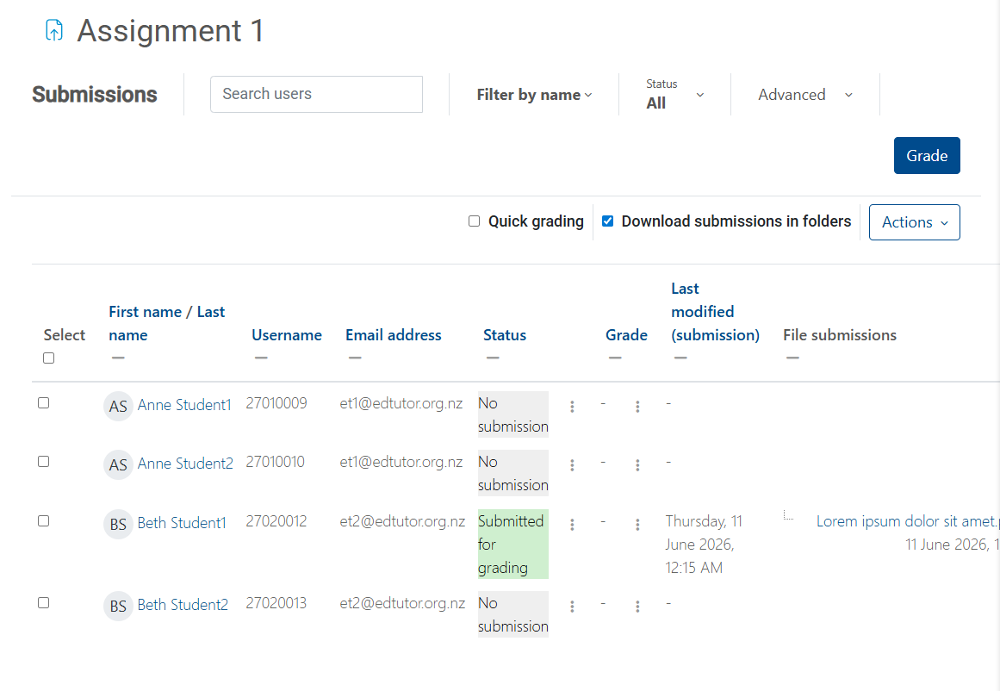
And there is full logging:
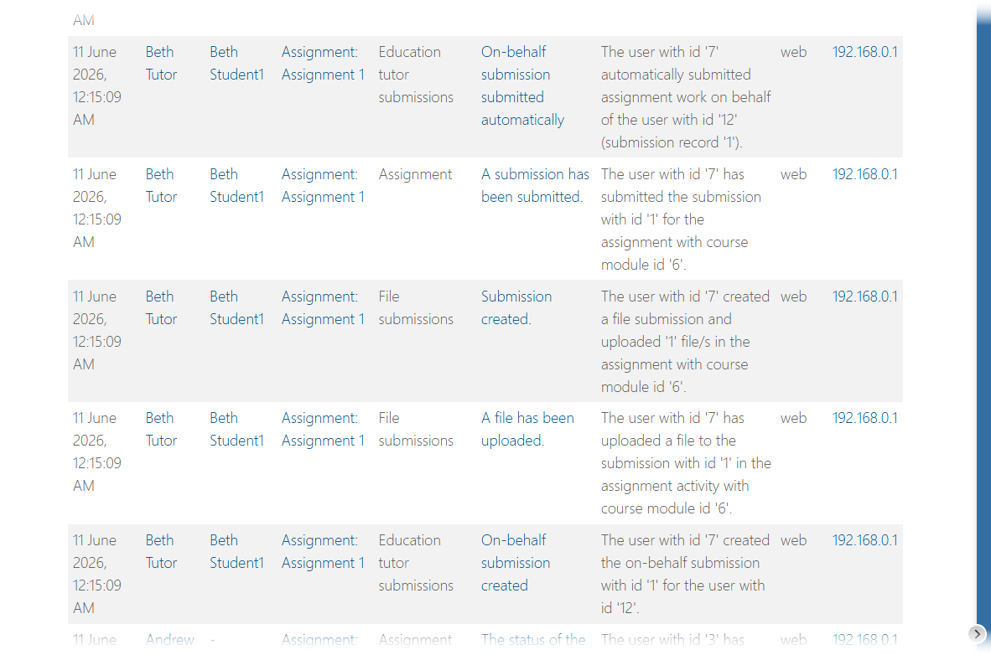

Loggin on in behalf
Education tutors can quickly “login as” any of their allocated students.
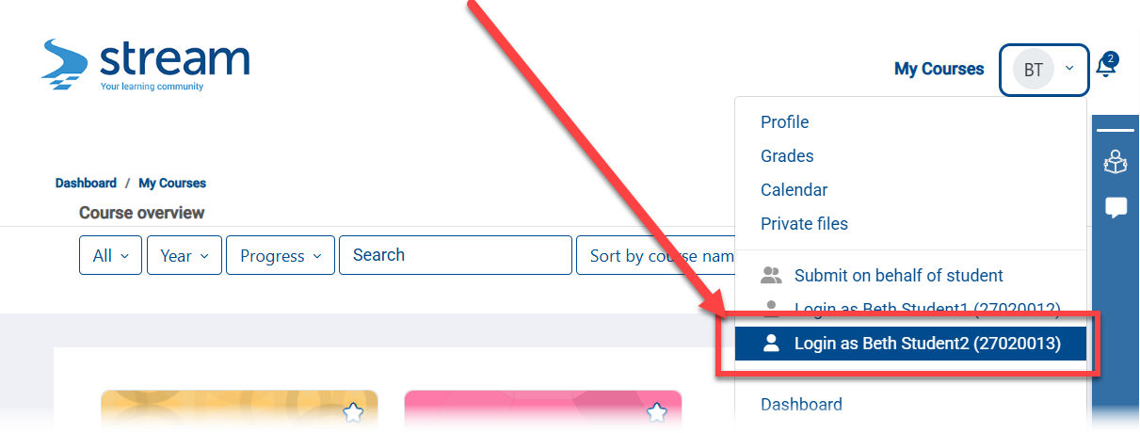

They can then see the students courses:
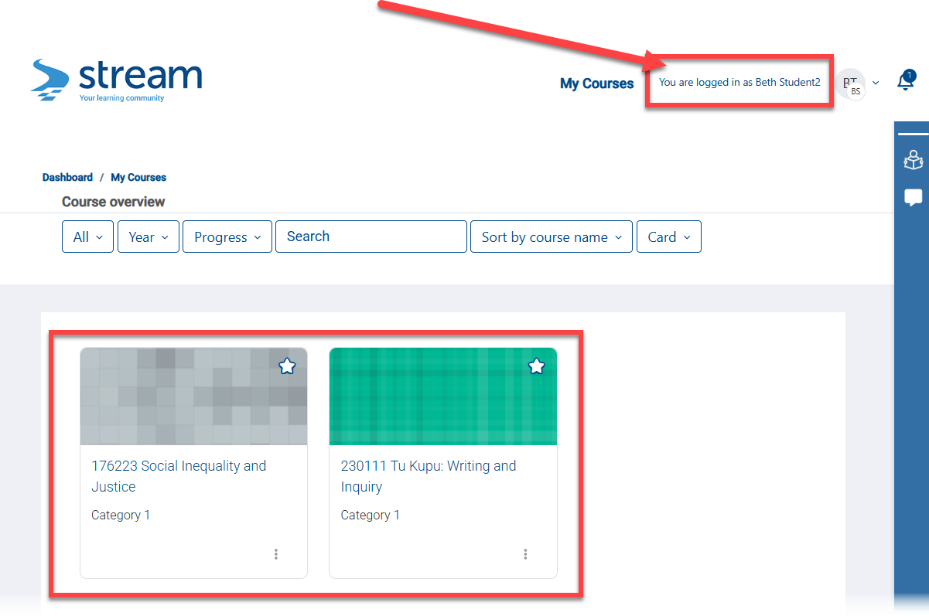

They can then engage with the course, view assignment feedback, and submit assignments directly.
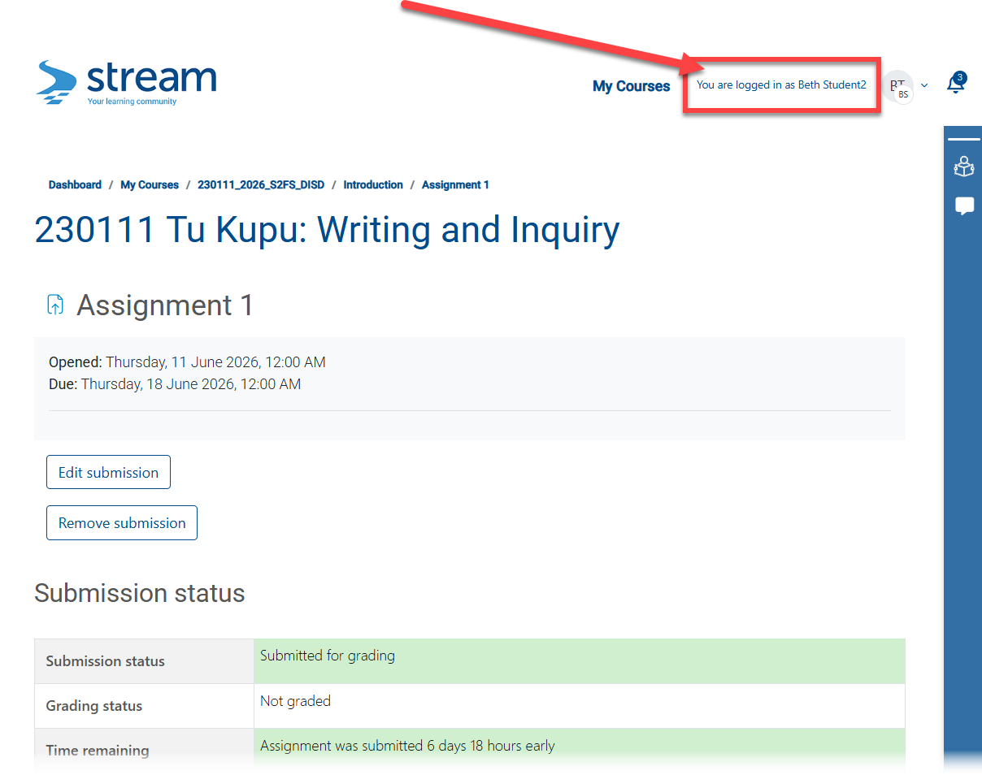

As a student, the Education Tutor can return to the dashboard:
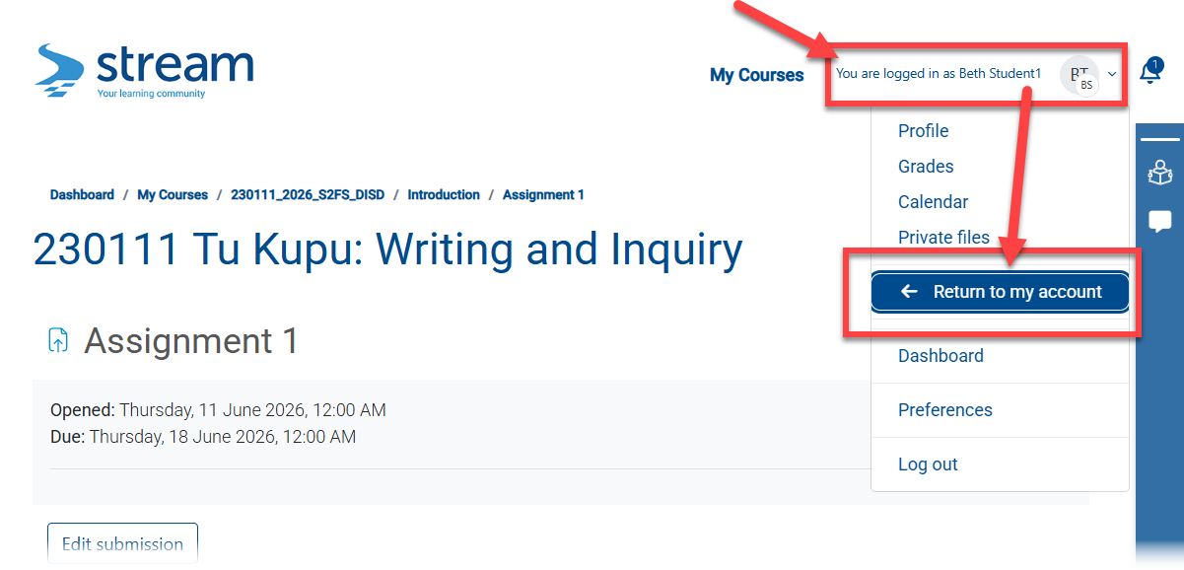
Note that this requires reauthenticating.

Set student preferences
An Education Tutor can directly set certain student preferences, e.g., Forum notification digest.

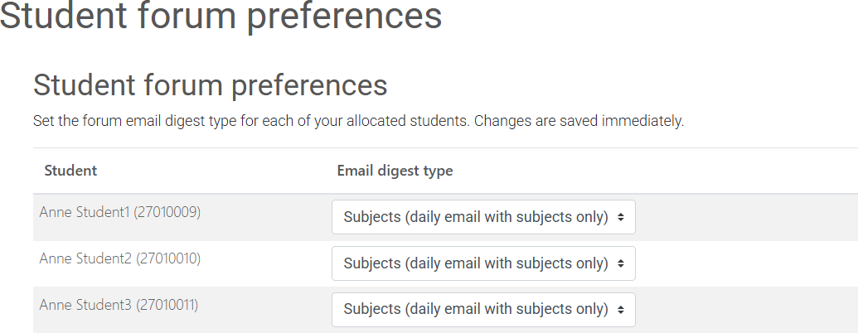

Education tutor manager experience

Tutor – Student Allocations
This feature is intended for central service units to administrator Education Tutors and their allocations. Multiple users can have this role, i.e., Claire, Toni, and others in the team.
Once tutors have been given an ST account and added to Stream, they can be linked to their students using a new administration screen.
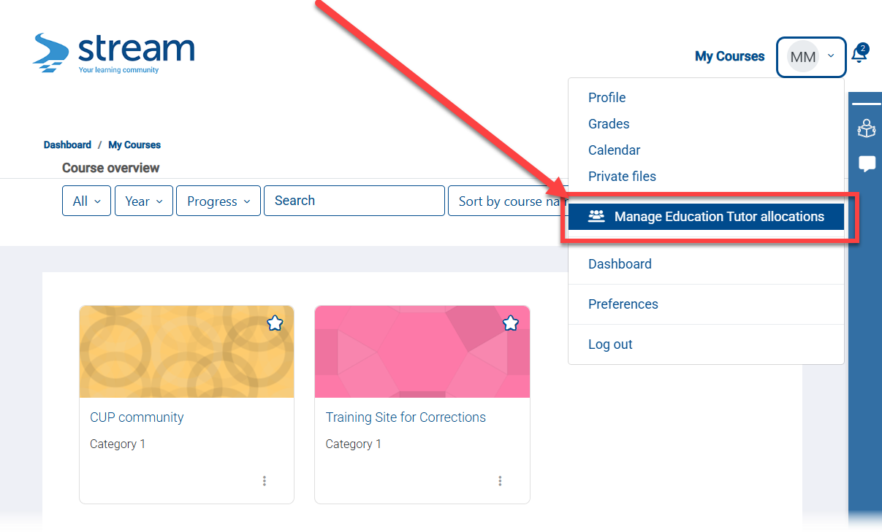
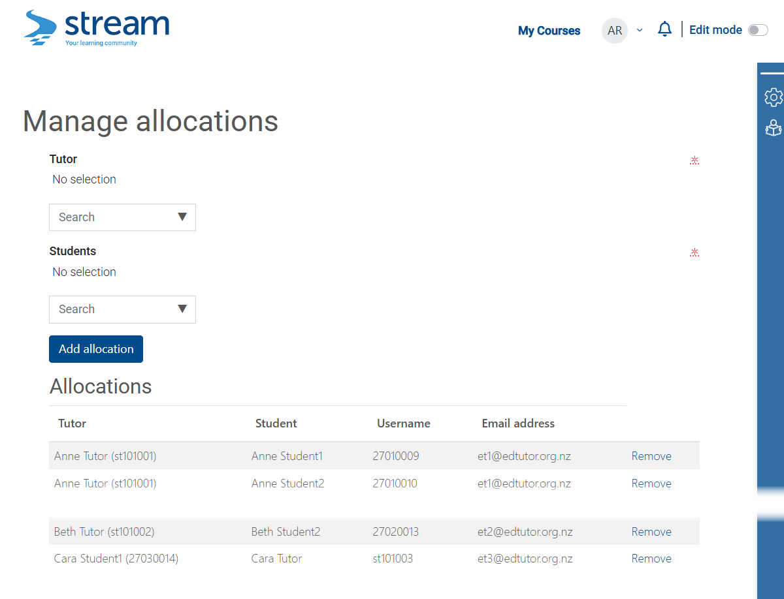
Students can be moved between Education Tutors at any time with immediate effect. Historical logs will still indicate the Education Tutor who took action at the time, i.e., submitted an assignment.

Stream support experience
Note: Only basic functionality has been worked up at this stage.
If submissions cannot be completed on behalf, the Education Tutor will be alerted at the time, and nominated support [Stream] staff will receive a message indicating that a submission requires manual intervention.
Education tutor view:
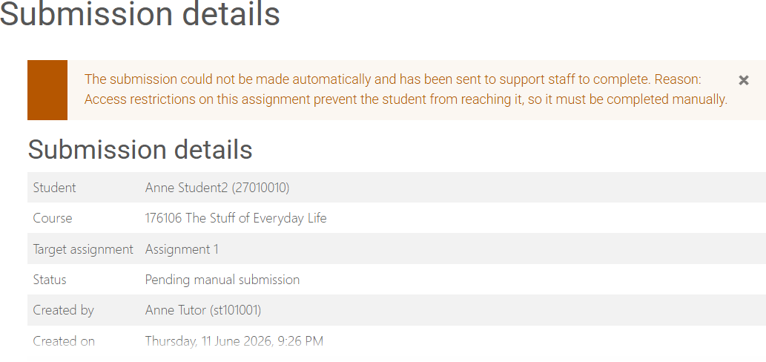

Support staff can access the submissions requiring manual intervention:
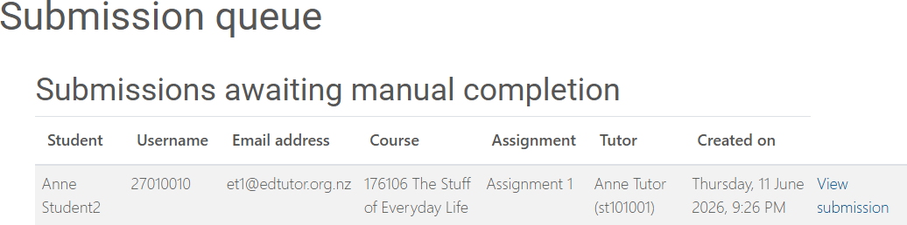

When viewed:
